Bandaging

- inside, outside, front, back
- keep tension on the back/tendons but don’t pull against them
- wrap bandage in same direction as pad
- overlap 1/3 to 1/2
- wrap parallel to ground
- leave 1/2 inch of pad showing
- you have the choice to cup on stable or not
- make sure you know you to use bandage pins even if you don’t use them for your wraps
- masking tape in a spiral
- for shipping, you can cover the pad completely and wrap onto the hoof, but not the leg, but some examiners may not like this
- naturally, people will make the top of the bandage tighter than the bottom, but it should be the same, so think about wrapping tight on the bottom and loose on the top
- when people flick the bandage, they are listening to hear if it makes the same sound all the way down (it should)
- be able to slip two fingers under pad w/o feeling your pulse
- if you use store-bought pads, make sure that you break them in first, by washing them two to four times and then wrapping with them several times before you actually need to use them at your rating

C1 | C2 | C3
-Stable, with assistance  “with assistance” means you can ask  them to hold things on the horse while  you wrap, and basically be extra hands  -your choice of legs  -examiners will let you redo it  -can use store-bought pillow wraps or homemade  -good to end on the outside | -Shipping and stable, no assistance  -on diagonal legs, your choice  -examiners will let you redo it  -can use store-bought pillow wraps or homemade  -you may have to sew two store-bought wraps together to make them long enough for shipping wraps  -good to end on the outside | -Shipping and stable, no assistance  -on diagonal legs, your choice  -examiners will let you redo it  -can use store-bought pillow pads (if they’re thick) for stable, but should usually use homemade pads for shipping for more thickness and a custom fit (directions on back)  -they will probably try to pull off the shipping bandage from the bottom so wrap onto the shoe at least twice  -must end on the outside
How to make a shipping pad:

- Measure from ground to bottom of hock/knee joint
- Four-five layers of quilt batting in the appropriate size
- Cover with sheet cotton
- Cover with cheesecloth (very Pony Clubby, but optional – you won’t be able to use it very often because the cheese cloth will fall apart)
- Quilt in diamonds (optional)

Stable | Shipping | Polos
Stable bandages aren’t used so much for protection as for support. They can be used to prevent filling or reduce swelling after hard work or injuries. You can choose to cup, which is wrapping under the fetlock joint (provides more support), or not, which is just a wrap on the cannon bone. Cupping isn’t just making the bandage longer, though; you have to shape it to the leg and support the fetlock, not just cover it. (The picture of the Dover Natural Leg Wraps (below) is just covering the fetlock without cupping. A cup will have a V in the front.) | Shipping bandages are used to protect the lower leg, coronary band, and especially the bulbs of the heel during travel. It also supports the horse while they stand in a trailer. Pony Club doesn’t really discuss shipping boots partly because, when the standards were set up, shipping boots weren’t as good as they are now. However, ones today are usually as protective or more protective (they can come up higher on the leg without binding) than bandages, but they don’t provide support. An alternative is to use a stable bandage under a shipping boot for long travel. | Pony Club does not allow/recommend polos until you’re a UL PCer because if you don’t wrap them correctly, it is easier to bow a tendon, etc. than other wraps because there is no padding underneath. You will mostly only see these for dressage (not in the ring, but at clinics) and they will usually be white or black. These are mostly included here so you don’t get them mixed up with the wraps/bandages. A common mistake with polos is to wrap them too high and/or too low: you want the horse to be able to move their joints freely. They provide support and protection to the fetlock and tendons.

Padding | Wraps/Bandages | Polos
These are from Dover: “The ‘Natural’ Leg Wraps” for $19.90 and $23.70. They are the only ones I know of that are thick enough for Pony Club. 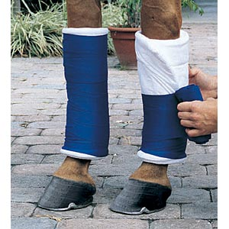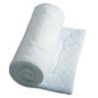 | These are from Dover: “Extra-Long Stable Bandages with Velcro” for $16.90. 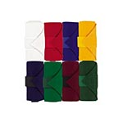 | 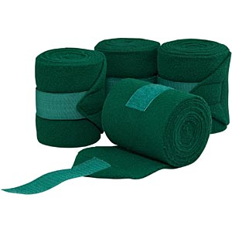  These are from Dover: “Polo Wraps” for $10.90. These are mostly included here so you don’t get them mixed up with the wraps/bandages.
Fronts for normal horse:  stable = 12 to 14 inches  shipping = 18 to 20 inches  Backs for normal horse:  stable = 14 to 16 inches  shipping = 20 to 24 inches  40 inches long | For normal horse:  stable = 9 to 12 feet  shipping = 18 (front) to 24 feet (back) –  two sewn together  6 inches wide | 9 to 11 feet  4½ inches wide
Store-bought are quilted cotton pads or sometimes foam, or homemade ones are quit-batting or cotton, sometimes covered in cheesecloth | Store-bought are usually track or knit with Velcro closure, but you can buy/make flannel ones, with or without Velcro | Made of fleece with Velcro closure

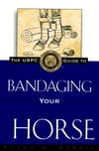

For more information, see The USPC Guide to Bandaging Your Horse by Susan Harris, which you can check out from the RVPC library.

